**Integrations:**

**To communicate one application with other applications**

**App- App**

**App-Database**

**While working on Integrations we can add int rules in 3 layers:**

**Organization Int Layer: ( ALFA- Int)  Use the data across the Application ( Connector Rules)**

**Implementation Int Layer( ALFA-ALFAAUTO-Int) : Accessed under Specific Division**

**Work Class Group Int Layer: (ALFA-ALFAAUTO -Work -Int) When we define Service Rules create under this layer (Services)**

**--------**

**Consumer:  Who will send the Request**

**Provider: Who Provides Response**

**Consumer:  To Consume the service we have to use Connector Rules**

**Provider: As a Provider we will define Service Rules**

**-When Applications are communicating they will follow a Protocol. In Protocol what Data Structure they can use will be defined.**

**Data Structures/Protocols**

**SOAP:**

**REST**

**To Transfer data b/w 2 applications we can use below formats:**

**JSON, XML, EJB, File, JCS**

**--**

**Services:**

**Request :  Parse -XML (  XML - Clipboard)**

**Response:  XML-Stream ( Clipboard - XML)**

**Connectors:**

**Request :  XML-Stream ( Clipboard - XML)**

**Response:  Parse -XML (XML - Clipboard)**

**XML - Stream: It will convert data from Clipboard to XML format**

**Parse- XML:  It will convert data from XML to Clipboard format**

**Integrations: The entire concept is Web services**

**SOAP: Simple Object Access Protocol**

**REST: Rest ful Protocol**

**Http: Hyper Text Transfer Protocol**

**MQ: Message Queue**

**--------------------------------------**

**Working with SOAP Protocol:**

**Services can be Predefined or user defined service**

**- Services SOAP Input we will get in a file format ( WSDL url)**

**WSDL: Web Service Description Language**

**To Test any SOAP Services we can use an application SOAPUI ( Third Party Application)**

**Rules to be created while working with SOAP Service:**

**Classes**

**Properties**

**Activity (Service Activity)**

**Service SOAP**

**Service Package**

**Parse -XML**

**XML-Stream**

**All these rules we create under Int Layer   (Which is under Class group )**

**Service Package: Collection of Multiple Services**

**Diff Services of similar / Same Access group can be created under one service Package**

**Service a Program with multiple methods.**

**========**

**Working With Service SOAP:**

**Req:**

**Build a Service for VIN Validation using SOAP Protocol.**

**- Request Property: VIN**

**- Response Properties: VIN, Brand, Model, Make Year**

**- The repository of VIN Details must be a table.**

**-----**

**Implement a Service for VIN Validation**

**1. Create VIN Table from Data Types Explorer:**

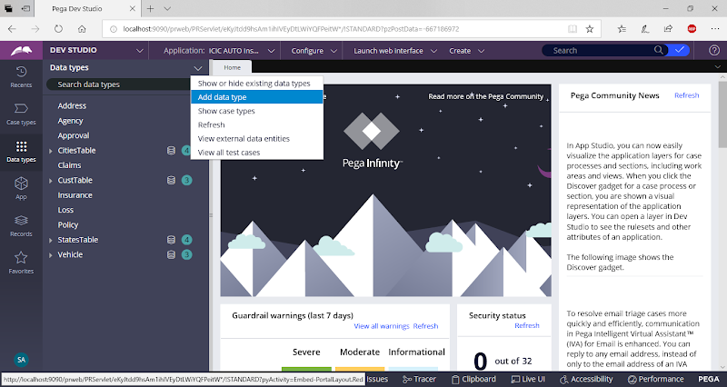

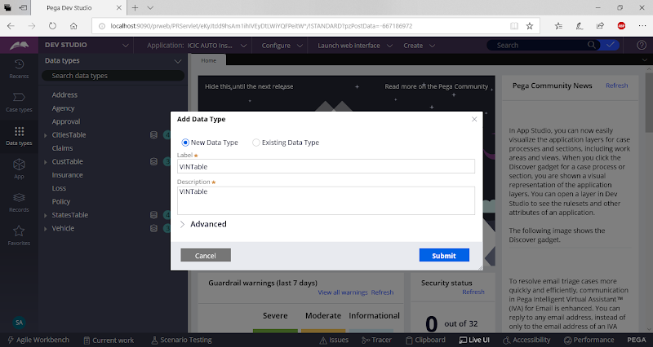

**Change Parent Class**

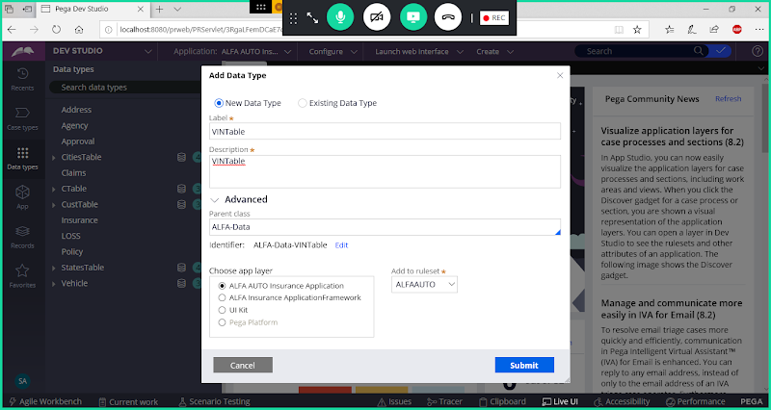

**Submit**

**Add Fields:**

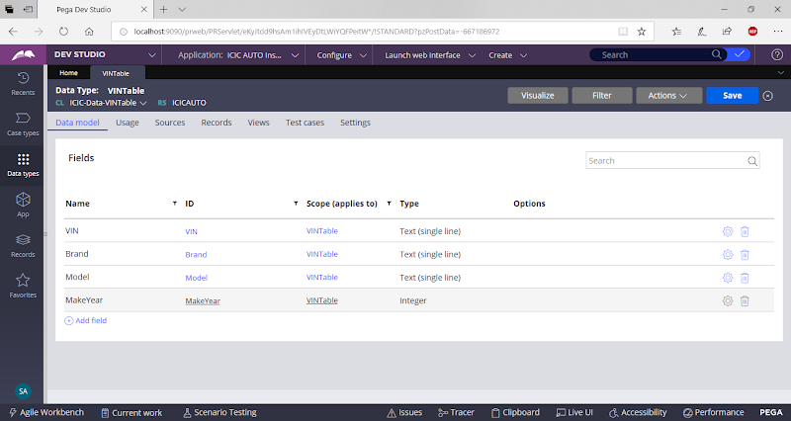

**Add Class Key ( VIN)**

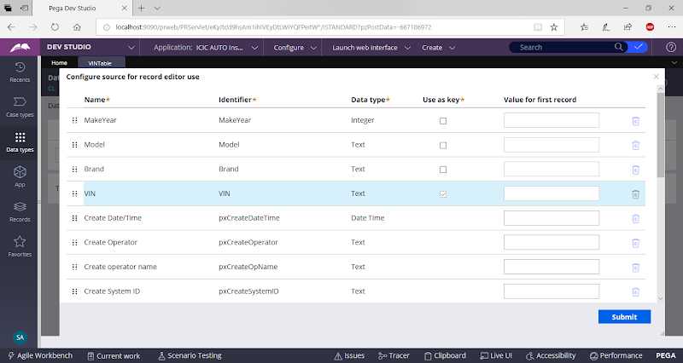

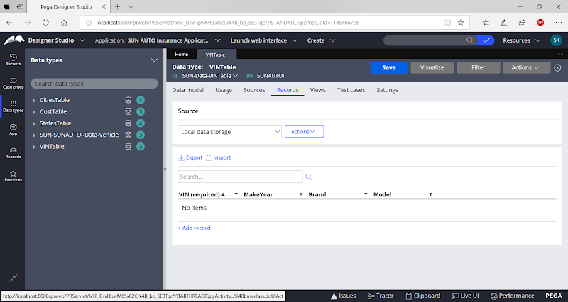

**Add Records manually**

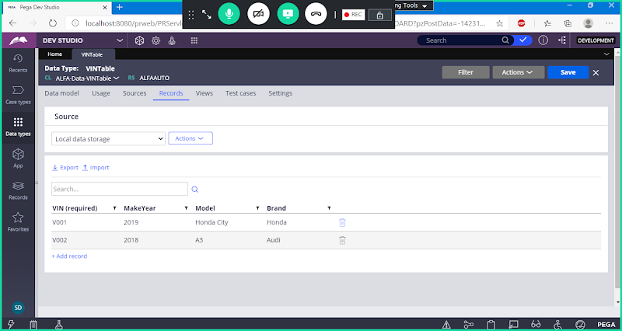

**When Creating Service Rules Create Int Layer under Class Group:**

**Add Int Class:**

**Add Int class under WOrk Layer:**

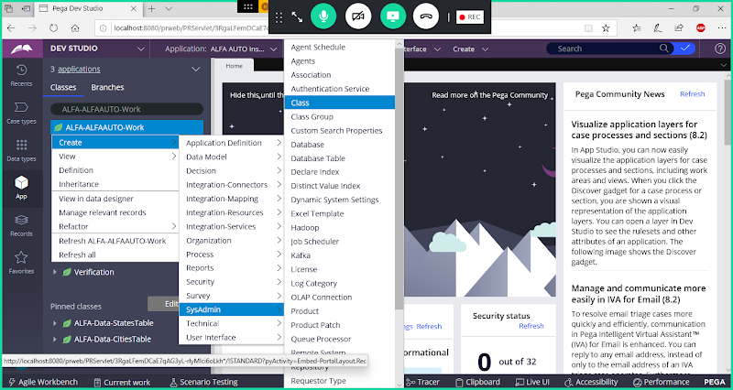

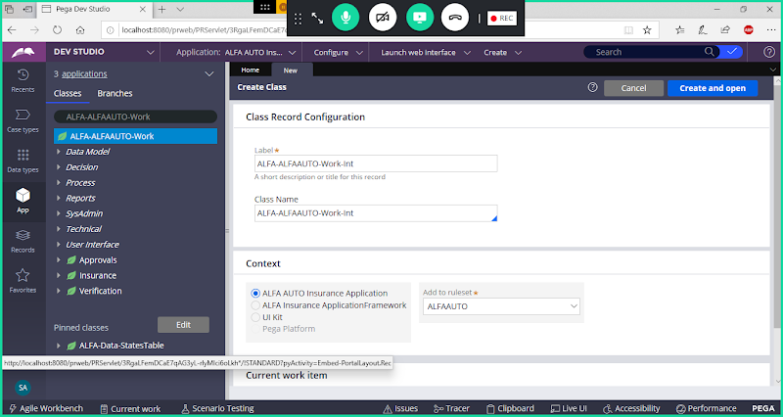

**open**

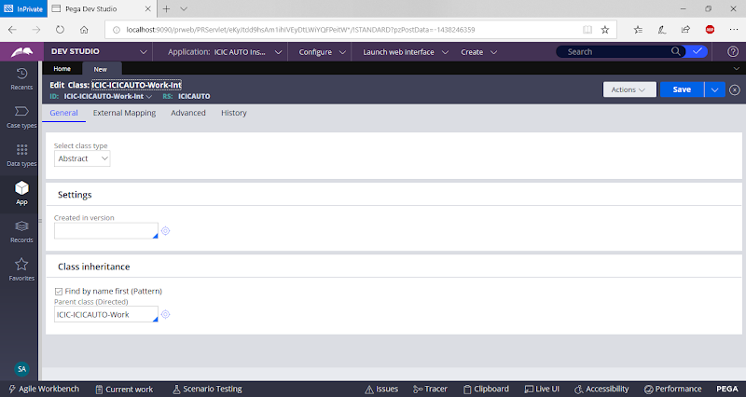

**Change Class**

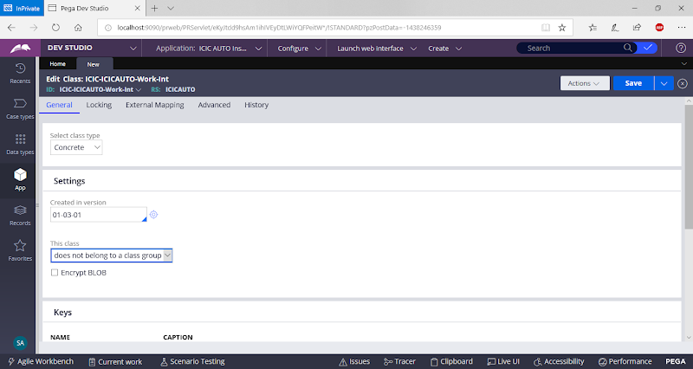

**Scroll Down & Change Parent Class to Int-**

**Add Direct Parent Class : Int-**

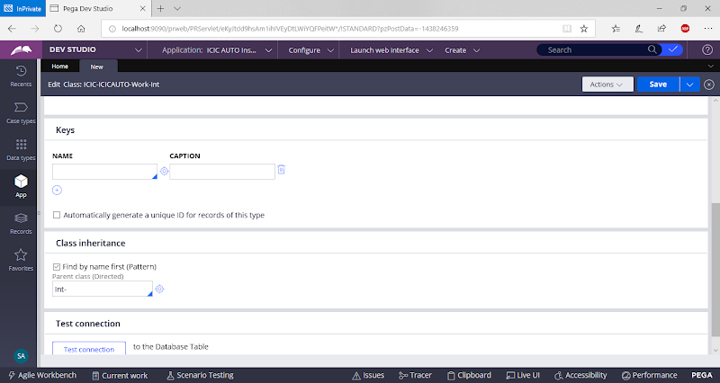

**Add History**

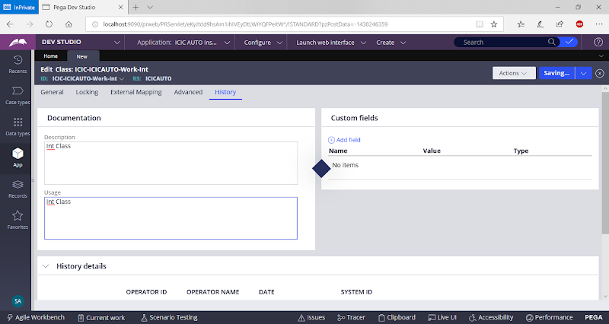

**Save Class & Refresh Explorer**

**Create Required Classes: ( Request & Response Classes)**

**Create a Request Class under Int Class: VINRequest**

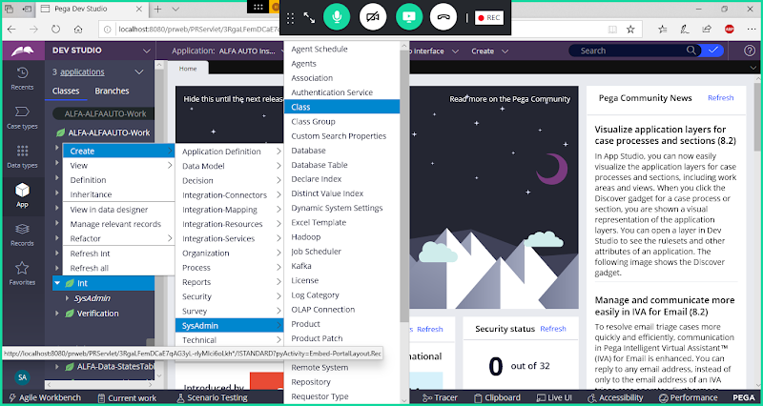

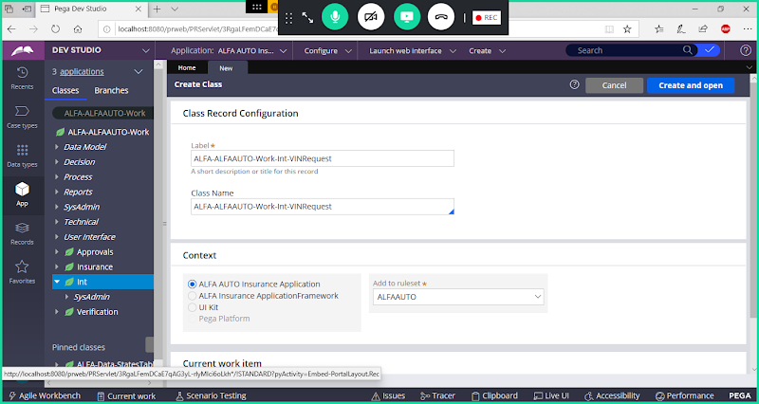

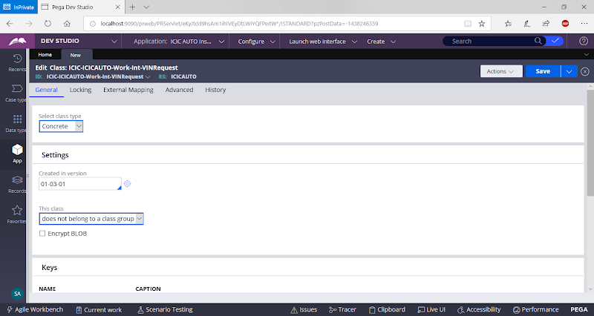

**Save Class**

**Create Response Class under Int Class: VINResponse**

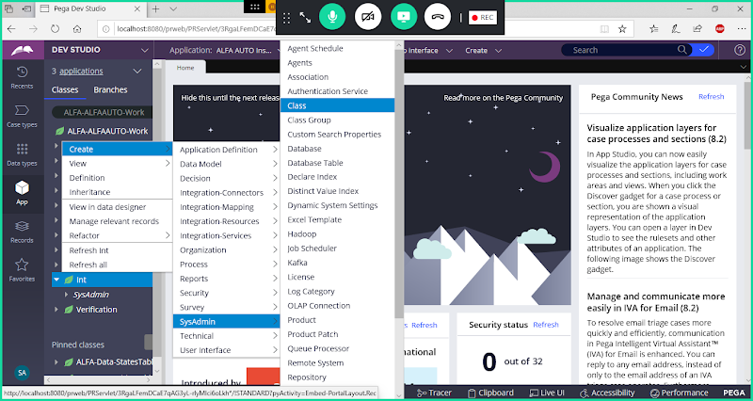

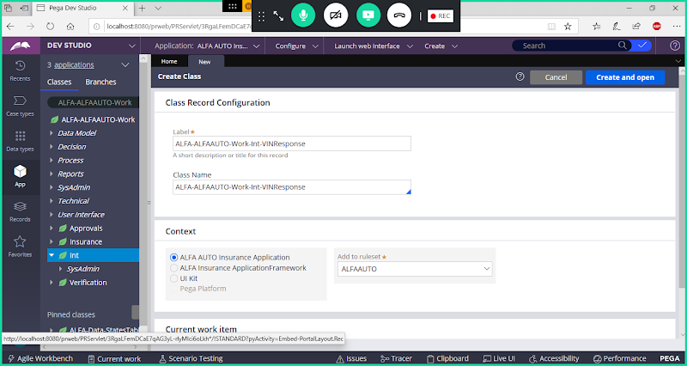

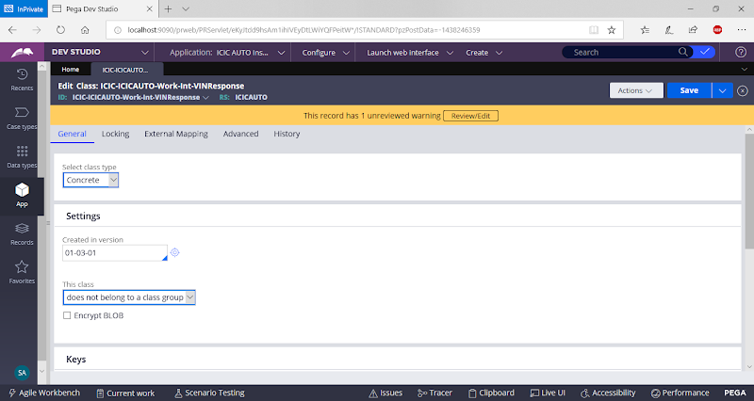

**Save Class**

**Add Request & Response Properties**

**Add Request Properties( Page Properties) Under VINRequest Class Referring to VIN Table Class:**

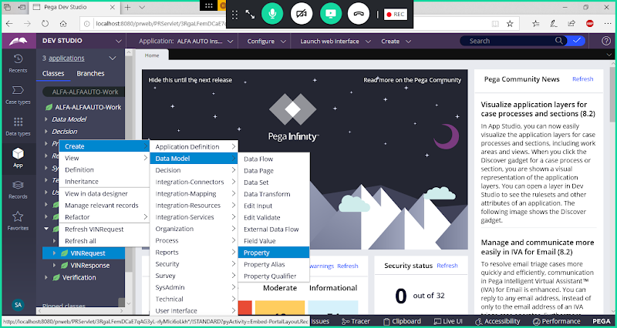

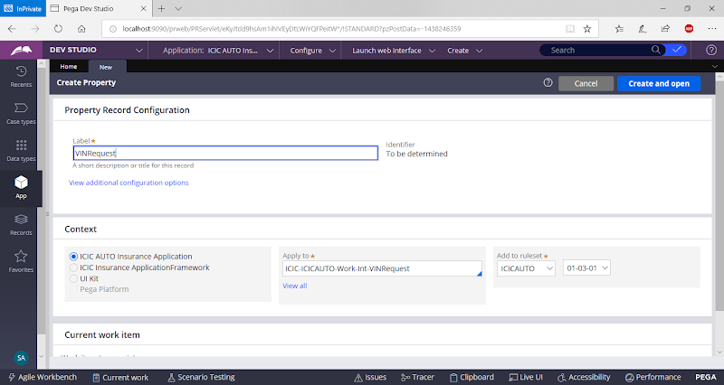

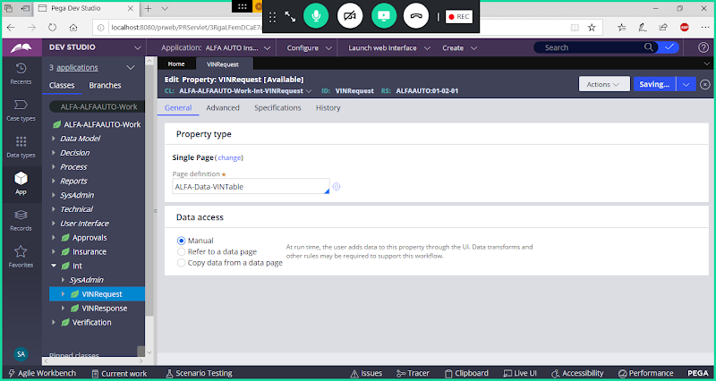

**Save Property**

**Add Page Property under VINResponse Class**

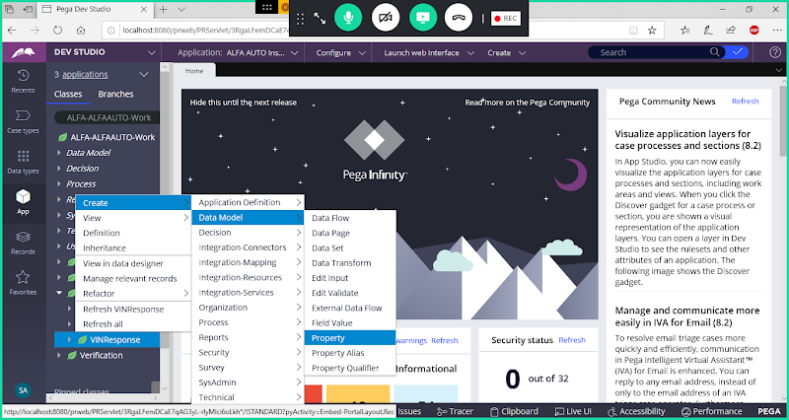

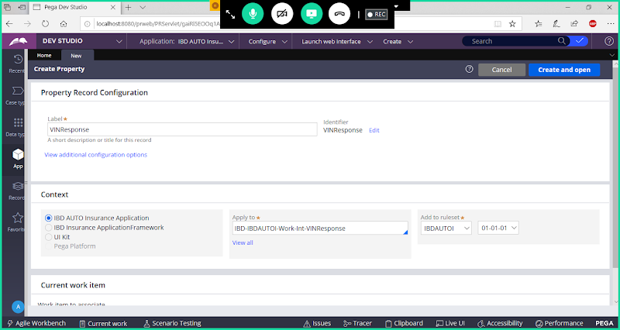

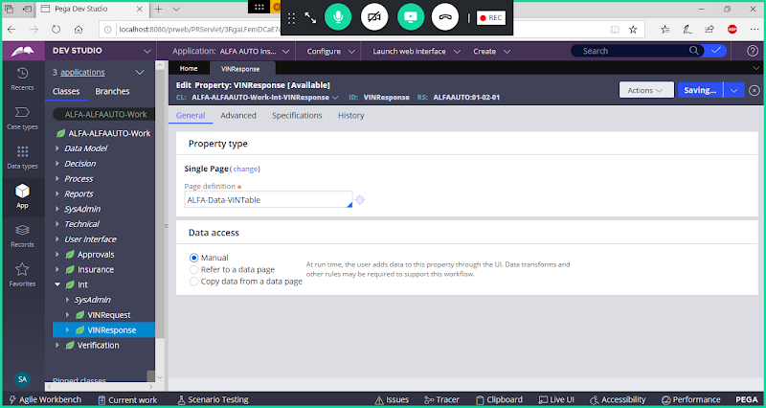

**Save Property**

**Create an Abstract Class for holding Service, Stream & Parse Rules, Request & Response Properties:**

**Abstract Class Create under Int Class:**

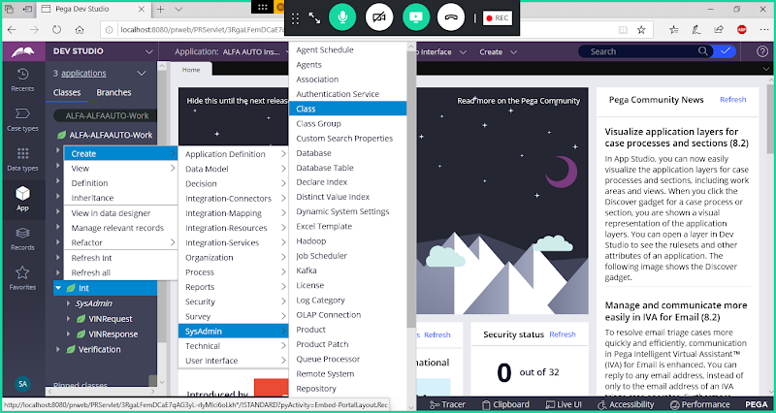

**Class Name: VINService**

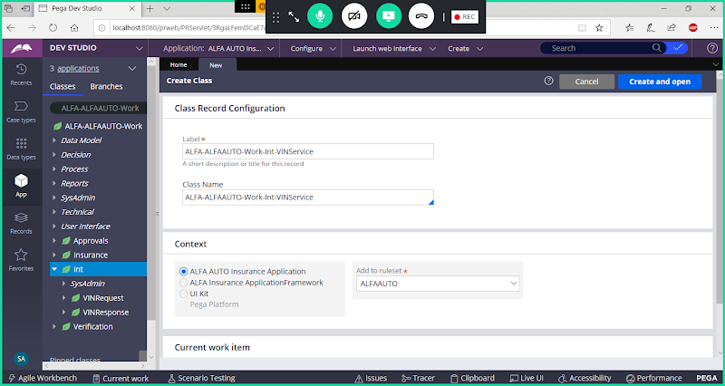

**Open**

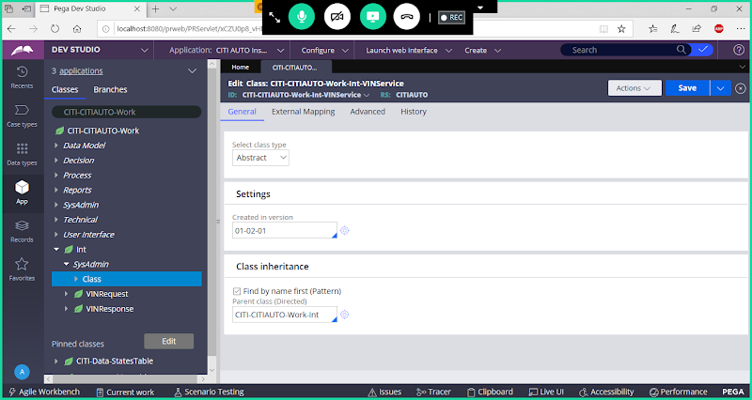

**Save Class**

**Again Create Page Properties for Request & Response under VINService Class:**

**Add VINRequestPage ( Page Property ) under VINService Class Referring to VINRequest Class:**

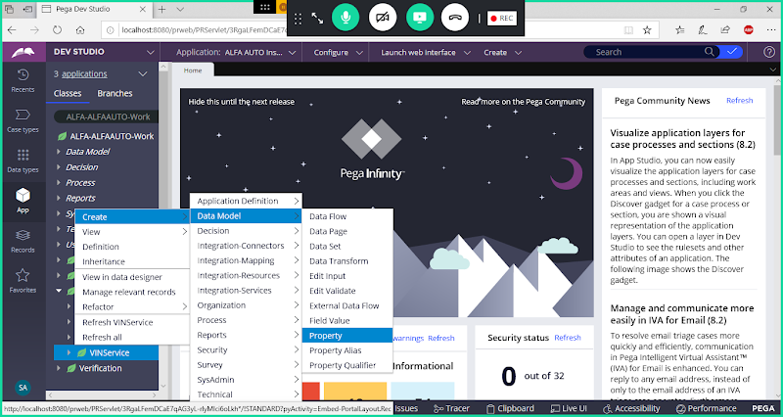

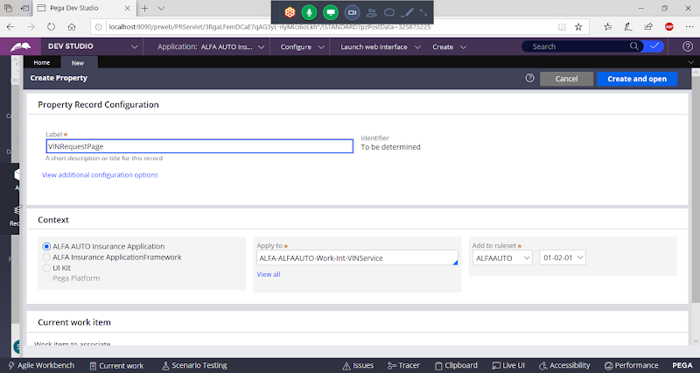

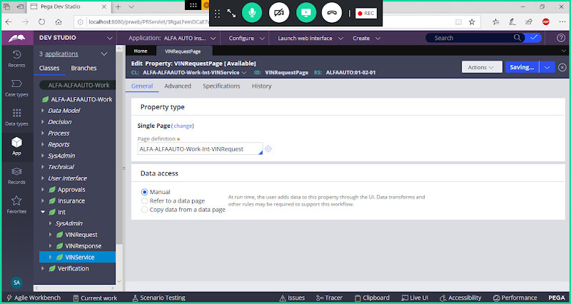

**Save Property**

**Create VINResponsePage under VINService Class referring to VINResponse Class:**

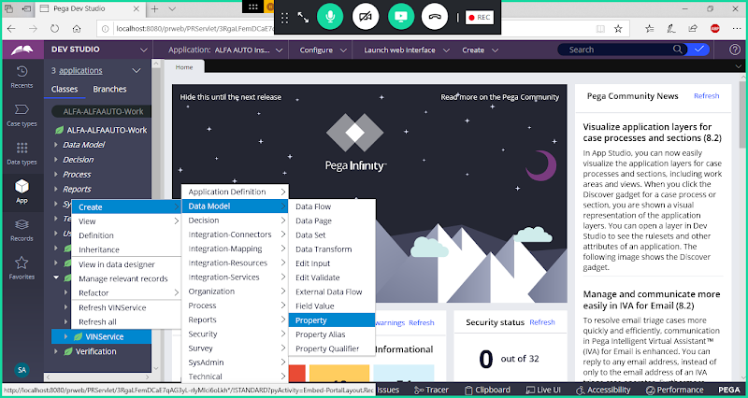

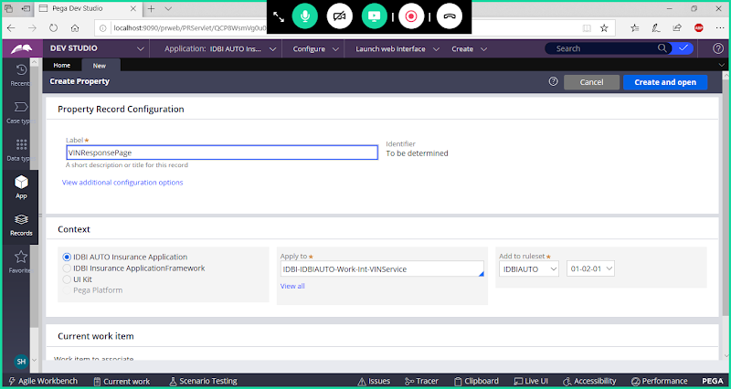

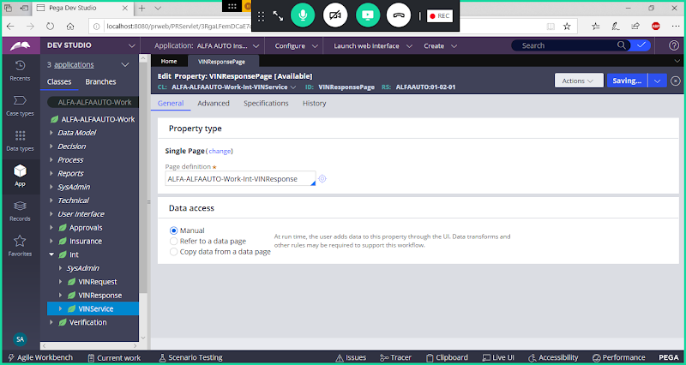

**Save Property**

**Create Parse Rule for Parsing Input Properties under VINService Class:**

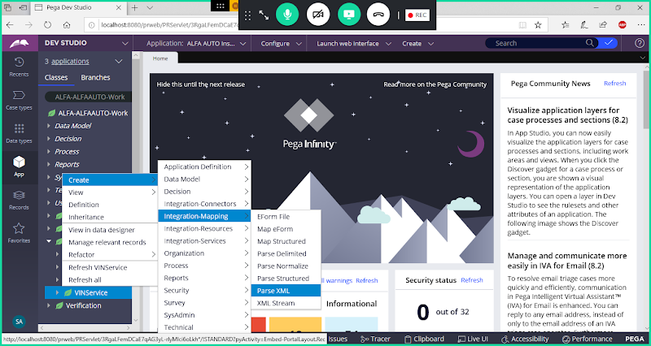

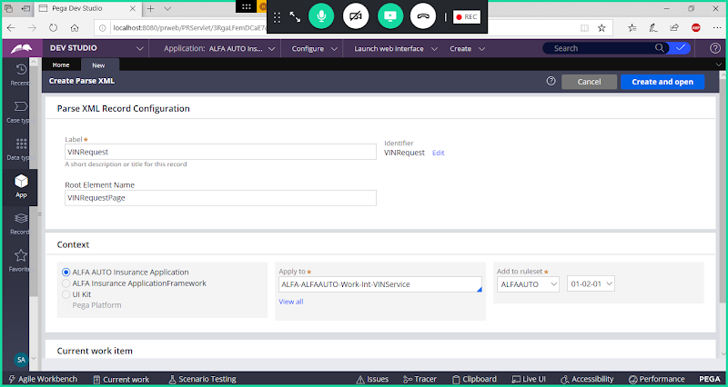

**open**

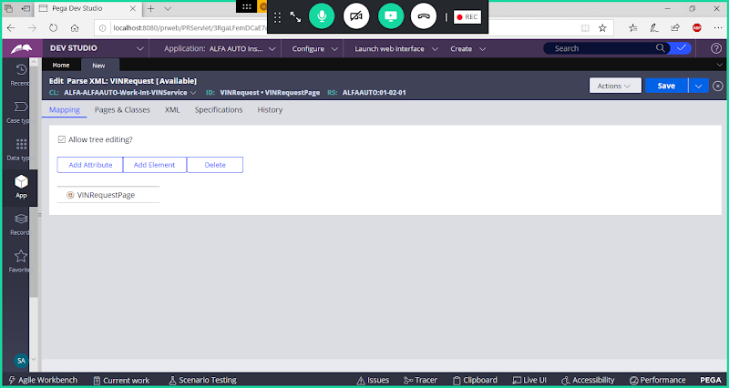

**Select VINRequestPage & Click on Add Element**

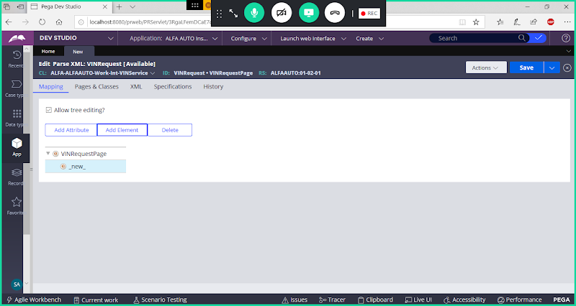

**Double Click on New**

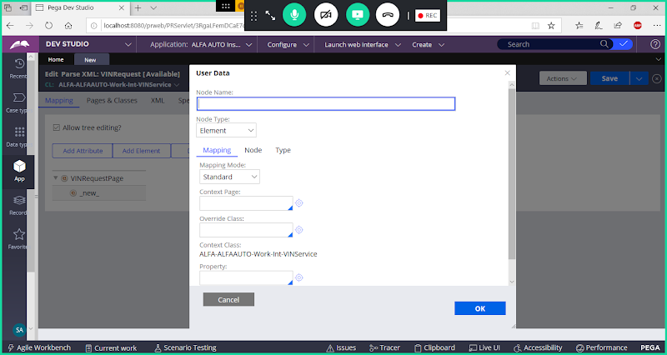

**NodeName: VIN**

**ContextPage: .VINRequestPage.VINRequest**

**Proeprty Name: VIN**

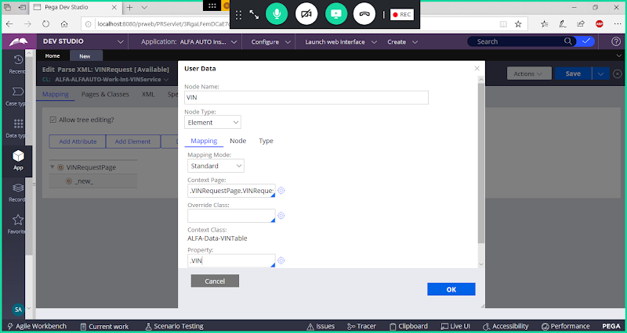

**Click on ok**

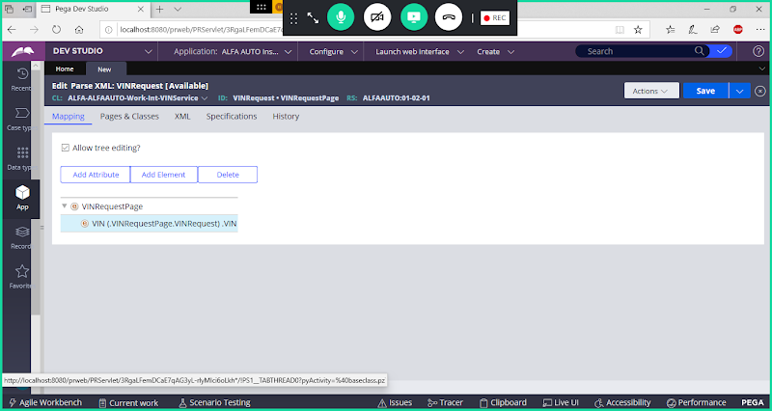

**After doing this mapping The Request will be mapped to .VINRequestPage.VINRequest.VIN**

**=============**

**Create XML Stream Rule for Sending Response:**

**Create under VINService Class:**

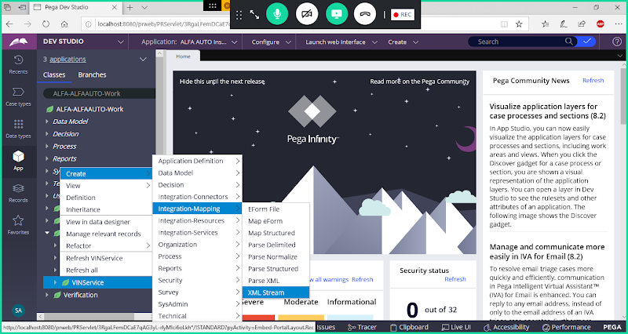

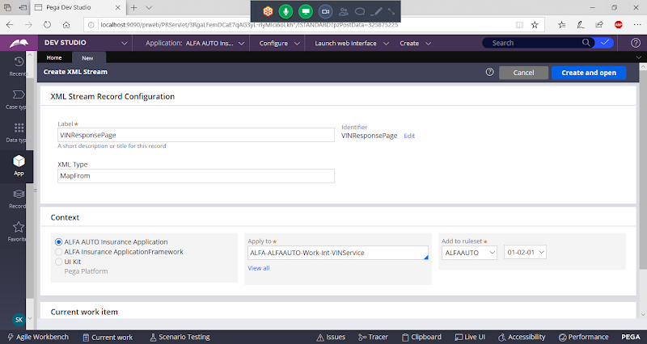

**open**

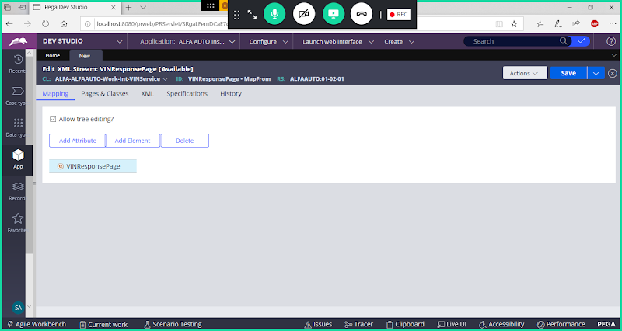

**Click on VINResponsePage & Add Element**

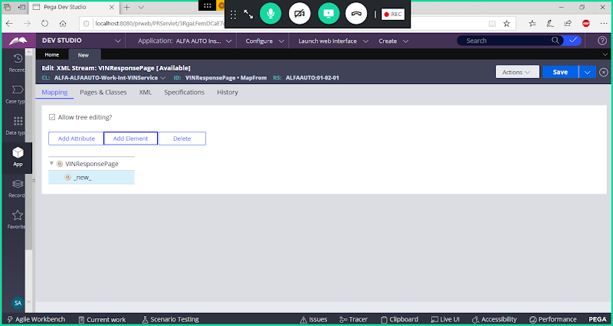

**Double Click on New**

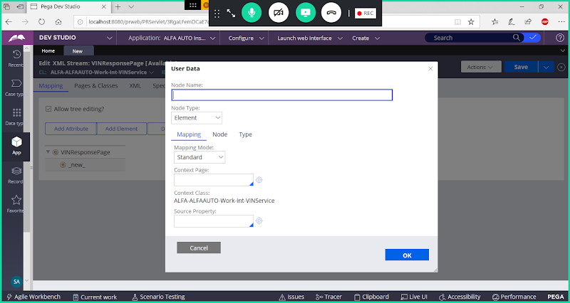

**NodeName: VINResponse**

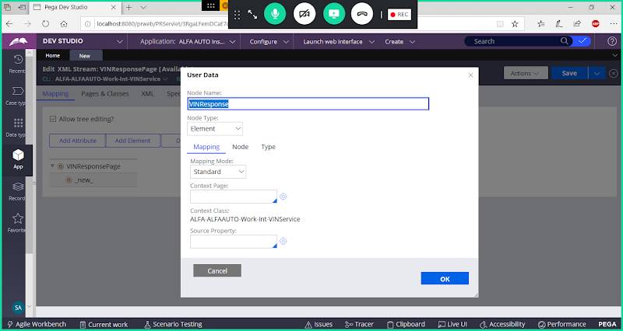

**Click on Ok**

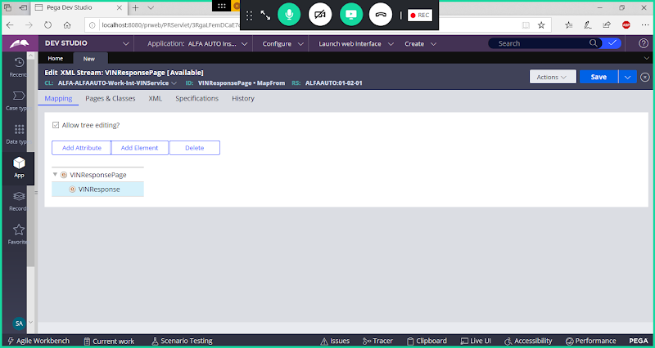

**Click on VINResponse & Add 4 New Elements**

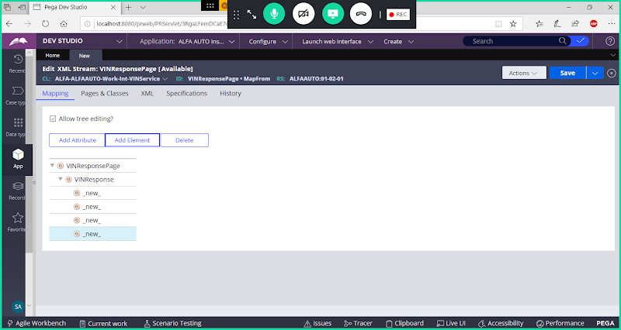

**Now Map Response Properties**

**Double Click on New to Map VIN:**

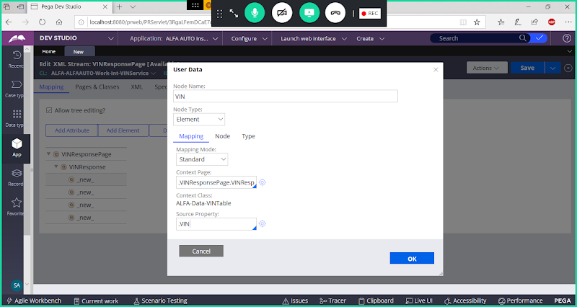

**Click on Ok**

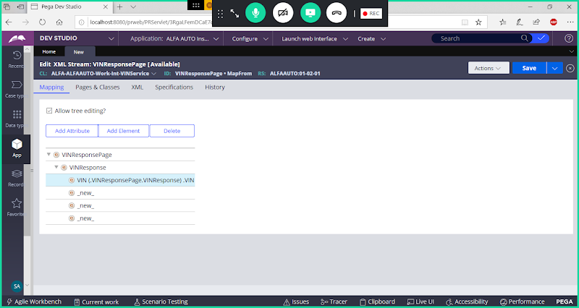

**Similarly map remaining Response Properties in other elements:**

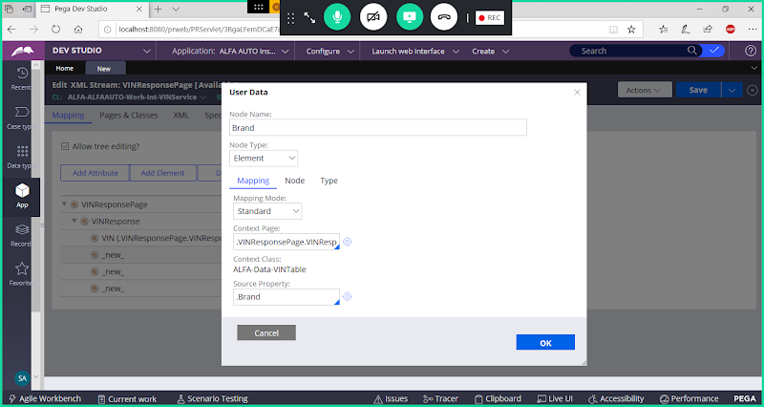

**Ok**

**Now Map Model:**

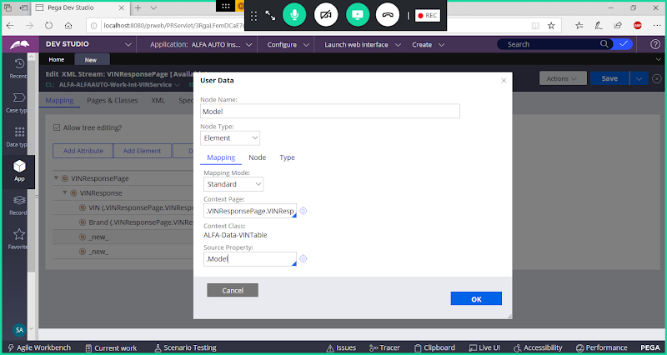

**Now Map MakeYear**

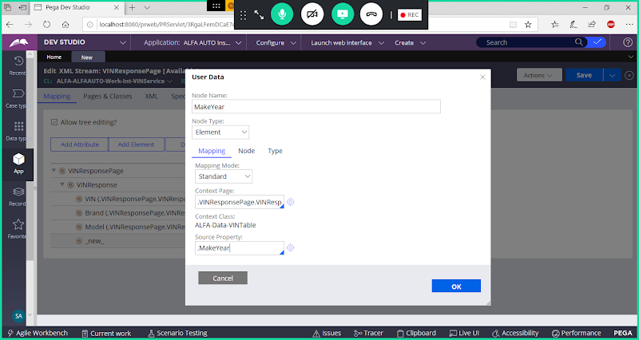

**Ok**

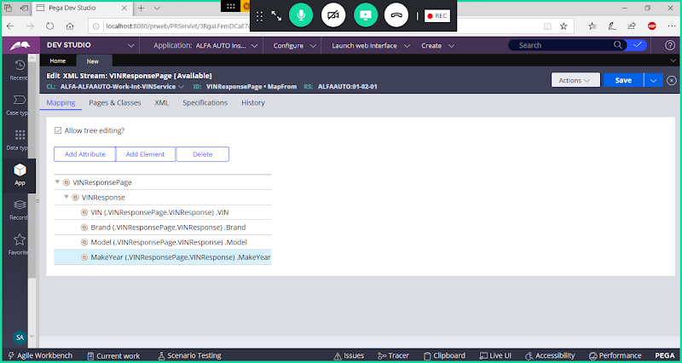

**Now Double Click on Main Root Element ( VINResponsePage)**

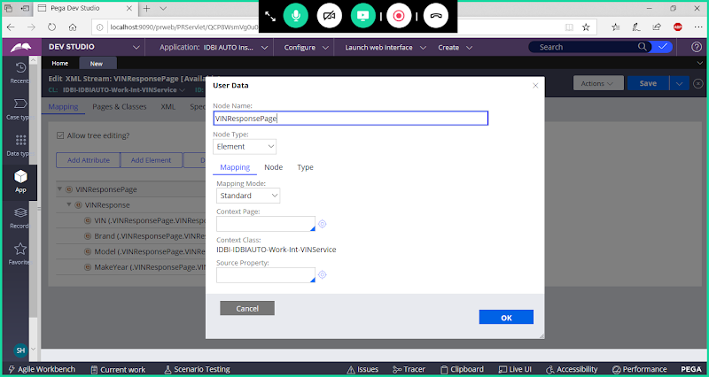

**Go to Node Tab:**

**Give Node Name in Node Name Space:**

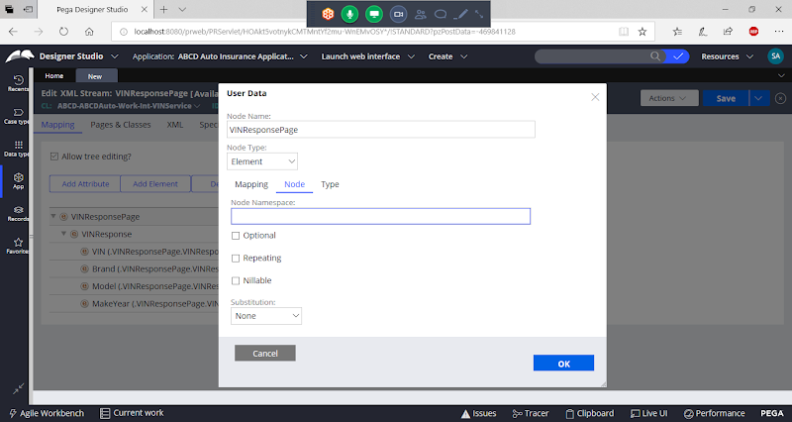

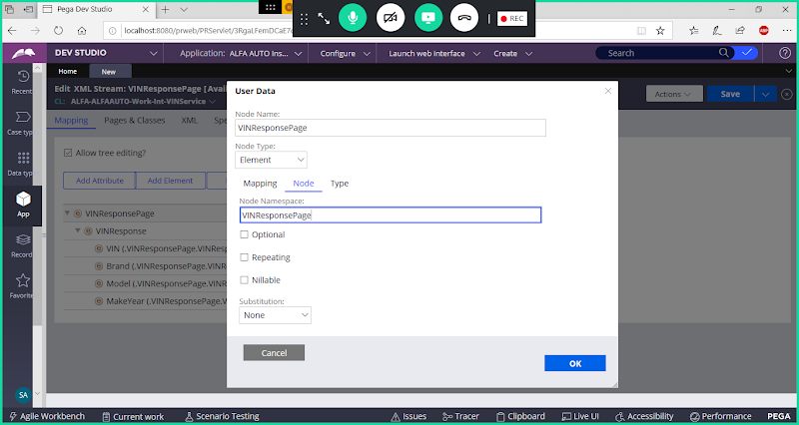

**Click on Ok**

**Save XML-Stream**

**======**

**Create a Service Package under VINService Class:**

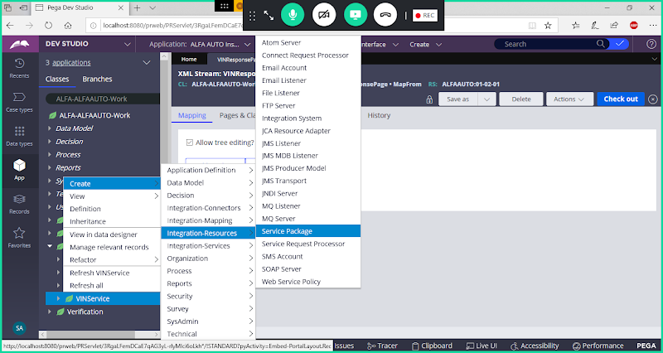

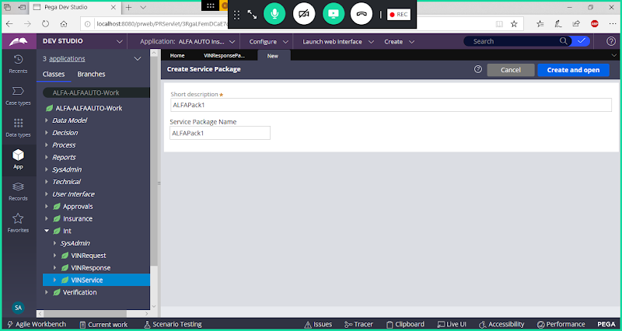

**Open**

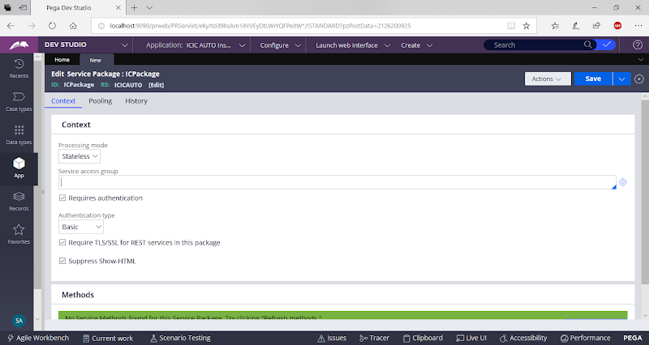

**Give Access Group Name: DivisionName: Administrators**

**Uncheck Requires Authentication:**

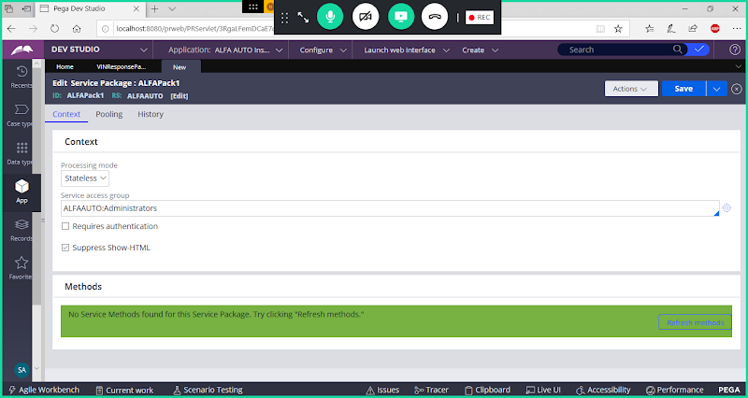

**Save Service Package**

**Create Service SOAP Rule:**

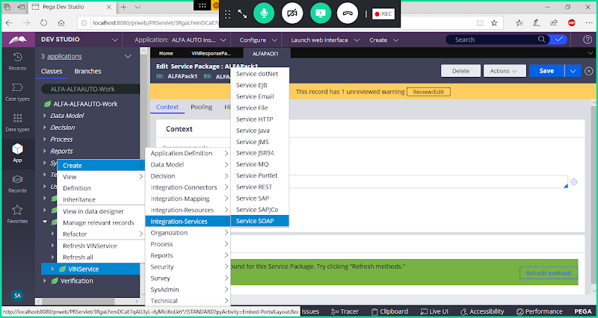

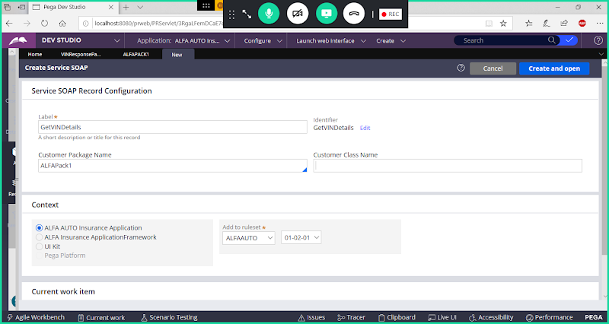

**Customer Class: VINValidationService**

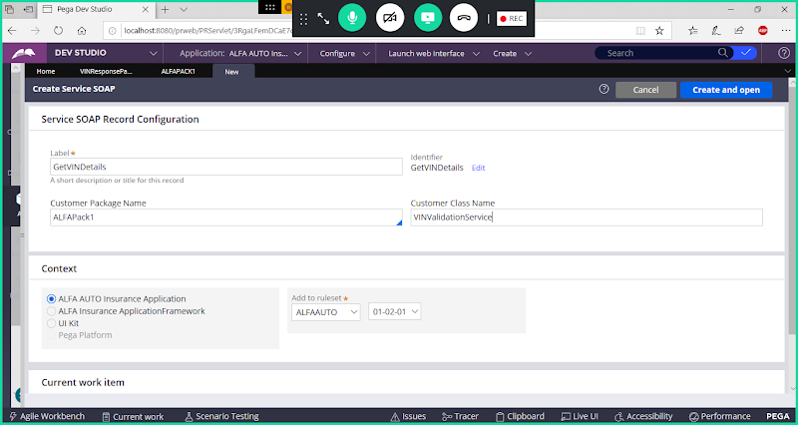

**Open**

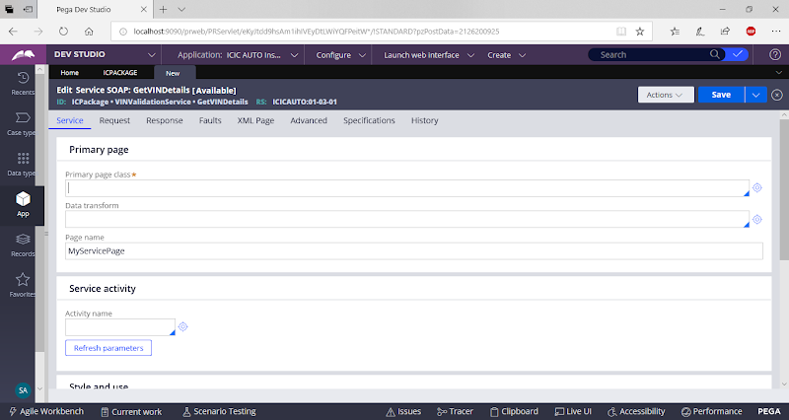

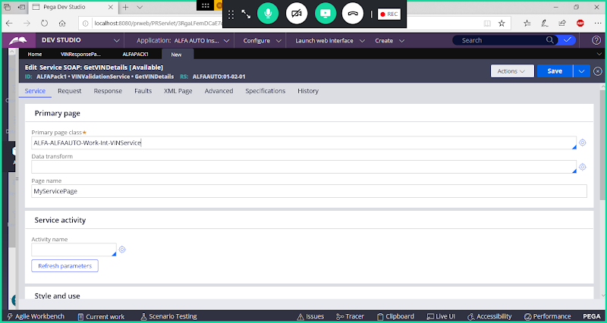

**Update Page Name to VINDetails**

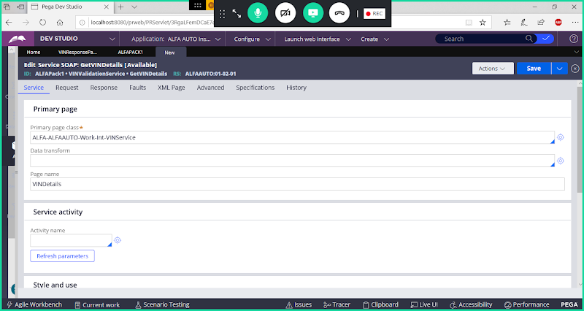

**Now go to Request Tab:**

**Configure Request Parameters**

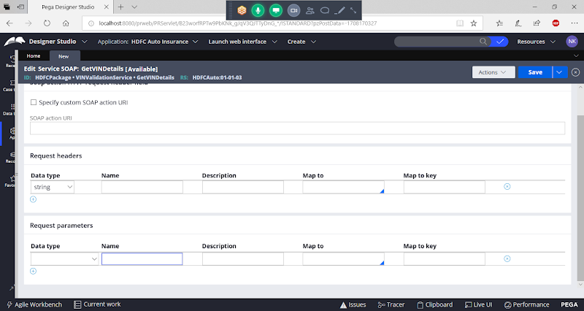

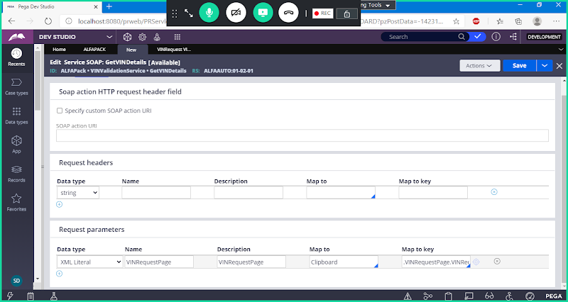

**Now go to Response Tab & Map Response Parameters:**

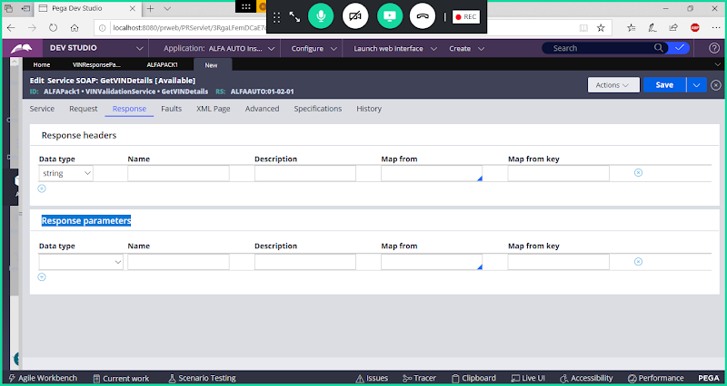

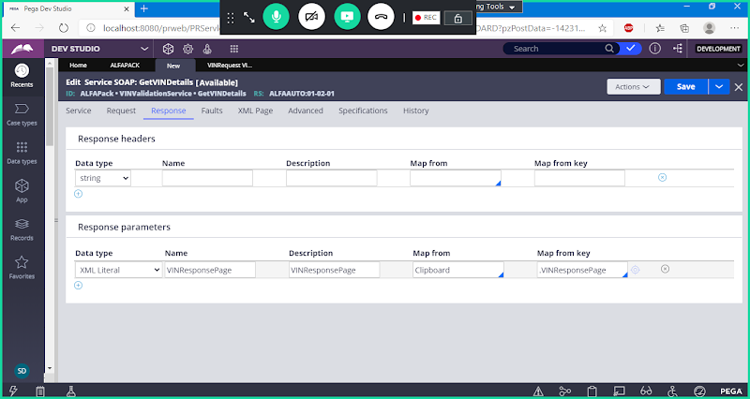

**Go to Service Tab:**

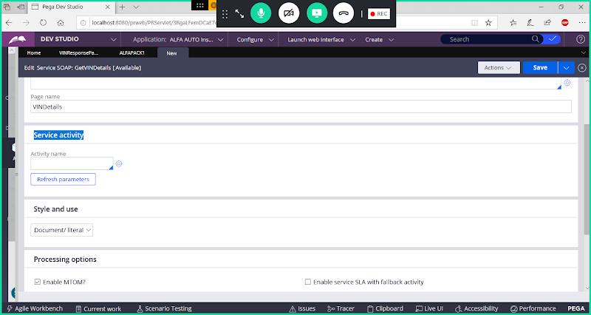

**Under Service Activity Give some Name & Open Activity from Service Rule:**

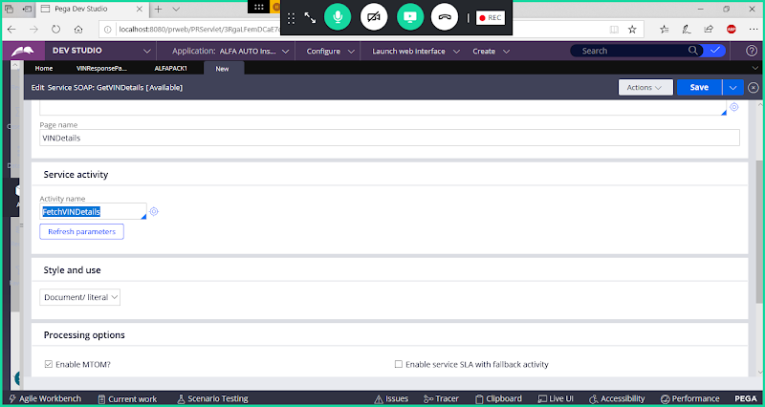

**Now We need to Create Activity  Rule, Open Activity Rule from Circle**

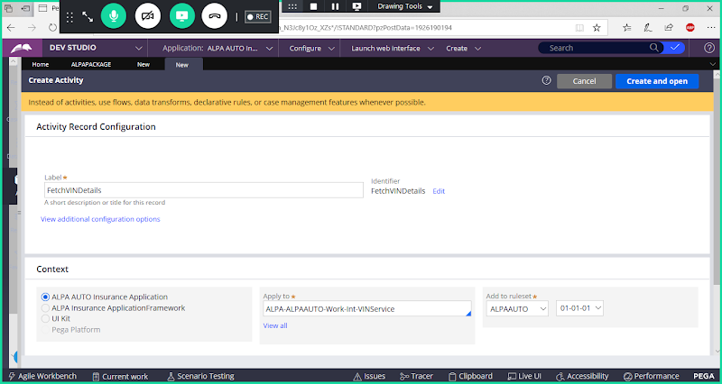

**Open Activity Rule & Go to Parameters Tab:**

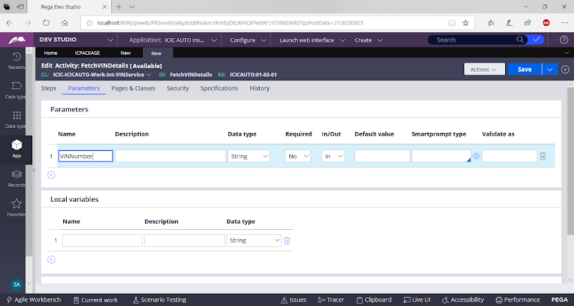

**Go to Pages & Classes**

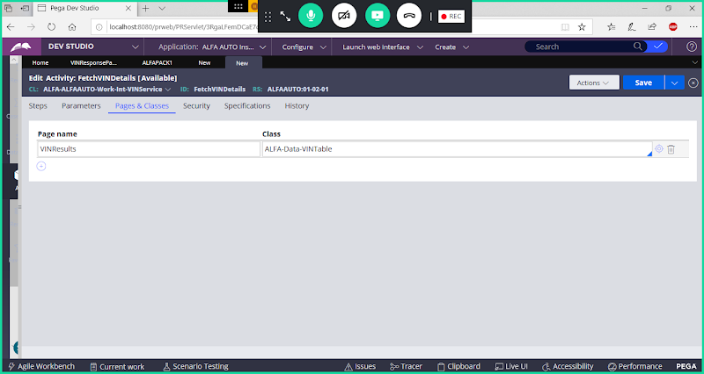

**go to steps Tab:**

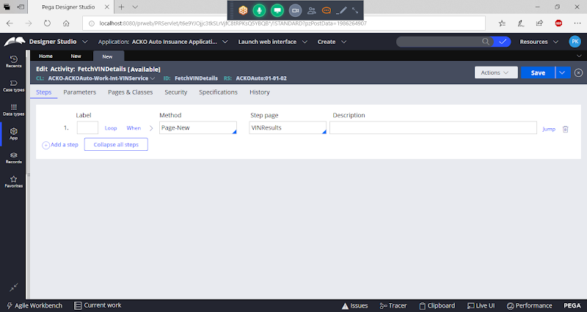

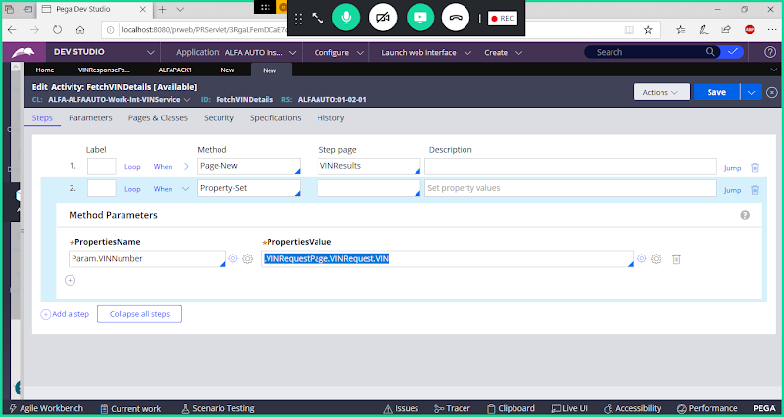

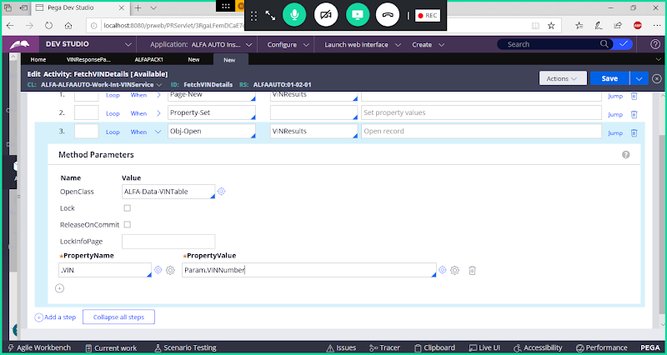

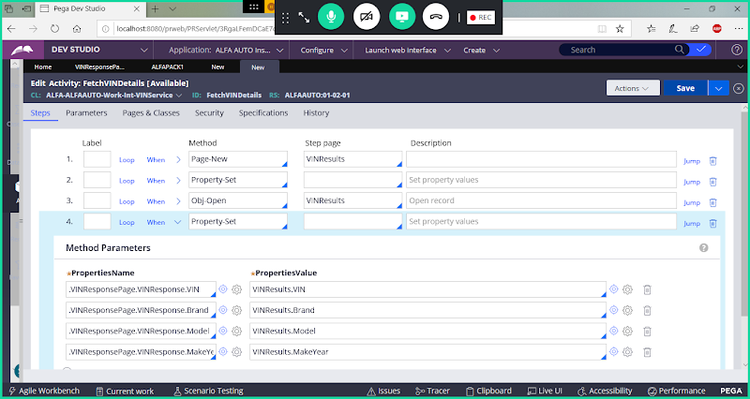

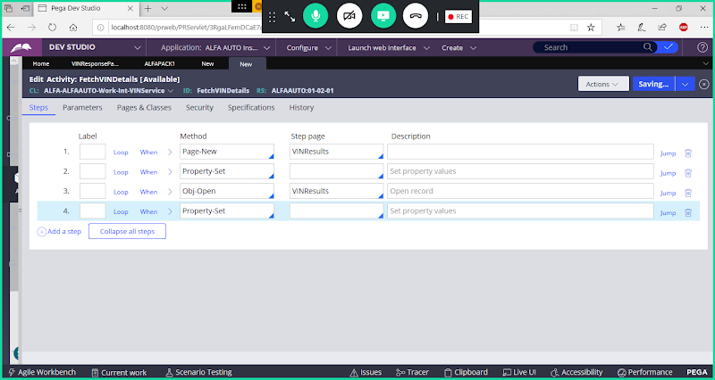

**Save Activity**

**Go Back to Service Rule & Save Service SOAP Rule**

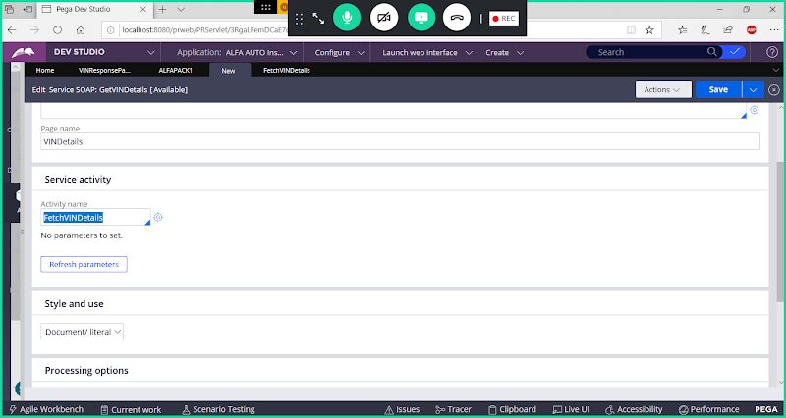

**Save Service**

**Now Open Service Package: ( Records-> Integration Resources-> Service Package)**

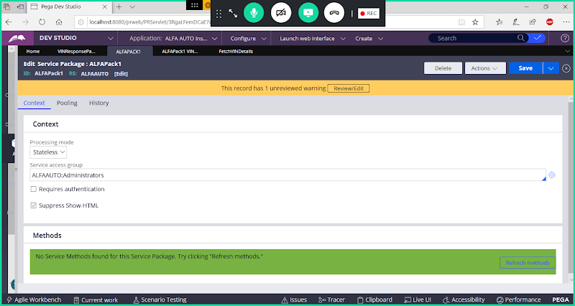

**Click on Refresh Methods Button**

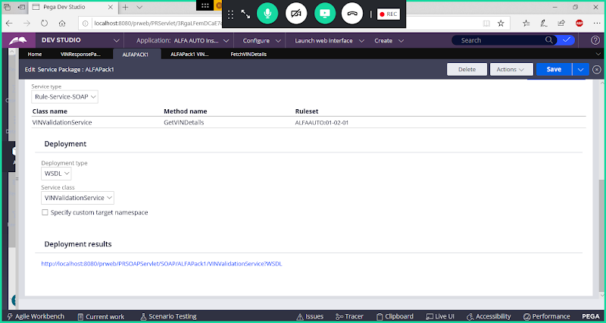

## Deployment results

## [http://localhost:8080/prweb/PRSOAPServlet/SOAP/ALFAPack/VINValidationService?WSDL](https://www.google.com/url?q=https://www.google.com/url?q%3Dhttp://localhost:8080/prweb/PRServlet/app/ALFAAUTO_/3RgaLFemDCaE7qAG3yL-rlyMIci6oLkh*/!PS2__TABTHREAD0?pyActivity%253D%252540baseclass.pzTransformAndRun%2526pzTransactionId%253Db3824e28f49d70ed232c2914e3dfeabf%2526pzFromFrame%253DpyWorkPage%2526pzPrimaryPageName%253DpyNewResults%2526preActivity%253D%2526preActivityParams%253D%2526action%253Ddisplay%2526harnessName%253DRuleForm%2526className%253DData-Admin-ServicePackage%2526pyDataTransform%253D%2526pyPreActivity%253DdoUIAction%2526pzPrimaryPage%253DpyNewResults%2526checkForNewPage%253Dtrue%2526portalName%253DDeveloper%2526contentID%253D_blank%2526readOnlyMode%253Dfalse%2526pzHarnessID%253DHIDED69F3ABE38F59BACDDFC86238E48FA5%26amp;sa%3DD%26amp;source%3Deditors%26amp;ust%3D1620641835678000%26amp;usg%3DAOvVaw1zcKWmyRxDhNEMP211O6jc&sa=D&source=editors&ust=1620641835709000&usg=AOvVaw2JSR6CChqsjQeLWdwwWRMo)